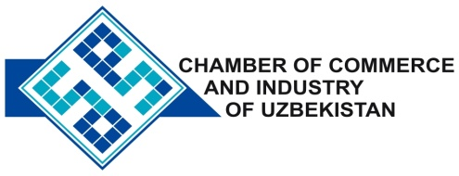

**Commercial offer of Uzbek Products to Foreign Buyer**

Dear Sirs, №KMOP - 004

We offer quotation of Uzbek Company Ltd «TASHKENT SHEKE INDUSTRY».

**Information about the company:**

The Company «TASHKENTSHEKEINDUSTRY» is registered in the public register of the Republic of Uzbekistan 13 November 2009. The main activity of the company is production of leather.

**List of products:**

Skins of cattle

The skins of sheep and goats

**Benefits:**

The company delivers only the highest quality and strict selection of raw materials last - guarantees high quality product.

**Terms of delivery:** FCA Tashkent

If you are interested, we are happy to provide additional information in accordance with your request.

E-mail: [export@chamber.uz](mailto:export@chamber.uz)

Website: [www.chamber.uz](http://www.chamber.uz)

Export Promotion Department.

Chamber of Commerce of the Republic of Uzbekistan.